 | 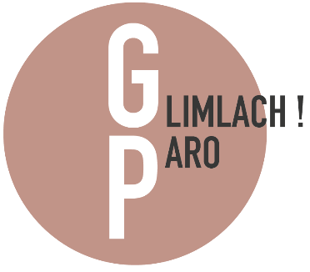
Verwijsformulier | Zuidpool 5 | 2801 RW Gouda  0182 – 55 55 55  E-mail: info@glimlachparo.nl  Website: www.glimlachparo.nl

 |  | Patiëntgegevens
Naam (met voorletters)  Geboortedatum  Straat, huisnummer  Postcode en plaats  E-mail adres |  | _____________________________________________________________ □ m □ v  _______________________________________ Telefoon______________________  _____________________________________________________________________  _____________________________________________________________________  _____________________________________________________________________
 |  | Verwijzer
Praktijk  Naam  E-mail adres |  | _____________________________________________________________________  ______________________________________________ □ Tandarts □ Mondhygiënist  _____________________________________________________________________
 |  | Parodontologie
□ | Advies parodontale behandeling |  |  | □ | Restauratieve chirurgie (bijv. kroonverlenging)
□ | Behandeling parodontitis (volledig) |  |  | □ | Mucogingivale chirurgie (bijv. recessiebedekking)
□ | Chirurgische behandeling parodontitis |  |  | □ | Second opinion
Toelichting |  | _____________________________________________________________________  _____________________________________________________________________  _____________________________________________________________________
 |  | Implantologie
□ | Plaatsen implantaat |  |  | □ | Plaatsen implantaat met suprastructuur
□ | Pre-implantologische chirurgie |  |  | □ | Behandeling peri-implantitis
□ | Implantologie edentaat |  |  | □ | Second opinion
Toelichting |  | _____________________________________________________________________  _____________________________________________________________________  _____________________________________________________________________
 |  | Aanvullende informatie
□ | Parodontiumstatus |  |  | □ | Röntgenfoto’s
□ | Medische aandoening |  | ___________________________________________________________________

